Step 1: Connecting to the Device

First, you need to establish a connection with the LiDAR hardware.

Select the Port: Find the device in the dropdown menu. If it doesn't appear, click the Refresh button.

Connect: Press the Connect button. The status indicator will turn green, and the label will change to "CONNECTED".

Note: For the initial connection, you may need to reset your Arduino/device and then click "Connect" within 15 seconds for it to enter configuration mode.

Step 2: Reading the Current Configuration

After connecting, it's best to load the device's current settings into the GUI.

Navigate to the Device tab.

Click the Read All from Device button.

This action will populate all the fields in the "Configuration" tab with the settings currently stored in the device's temporary memory (RAM).

Step 3: Setting Thresholds

The core of the configuration is setting the detection thresholds for distance and velocity for each of the 8 switches.

Go to the Configuration tab.

In the Thresholds section, enter the desired values for Distance (cm), Vel Min (mph), and Vel Max (mph) for each switch.

Refer to the notes on the right for operational limits and velocity direction conventions (negative values are towards the sensor).

Step 4: Configuring Trigger Rules

Define the logic that determines when an output will trigger. Each output can be made dependent on a combination of an external trigger, an external enable signal, and the LiDAR's own trigger conditions.

In the Trigger Logic Rules section, use the checkboxes to define the conditions for each of the 8 switches.

When the "Trigger" checkbox is checked, a "💥" icon will appear, indicating that this switch is armed to fire.

Step 5: Adjusting General Settings

You can configure the device's primary operational mode and debug output.

In the General Settings section, use the radio buttons to select either Distance Only Mode or Distance + Velocity Mode.

The Enable Debug Output checkbox can be used for troubleshooting but may slow down the device's responsiveness.

tag

Step 6: Writing the New Configuration to the Device

After you have entered all your new settings, you must send them to the device. This action writes the settings to the device's RAM, which is temporary.

Navigate to the Device tab.

Click the Write All to Device button.

This sends all the settings from the Thresholds, Trigger Rules, and General Settings sections to the device at once.

Alternatively, you can write settings from each section individually using the "Write" buttons within the "Configuration" tab.

Step 7: Saving the Configuration to Flash Memory

Settings written to RAM will be lost if the device loses power. To make them permanent, you must save them to the device's non-volatile flash memory.

On the Device tab, click the Save All to Device Flash button.

A confirmation prompt will appear. This is the final step to ensure your settings are saved permanently on the device.

Step 8: Saving and Loading Configuration Files

You can save your entire GUI setup to a file on your computer. This is useful for backing up configurations or quickly programming multiple devices with the same settings.

Go to the Device tab.

In the Configuration File section:

Click Save to File to save the current GUI settings into a .json file.

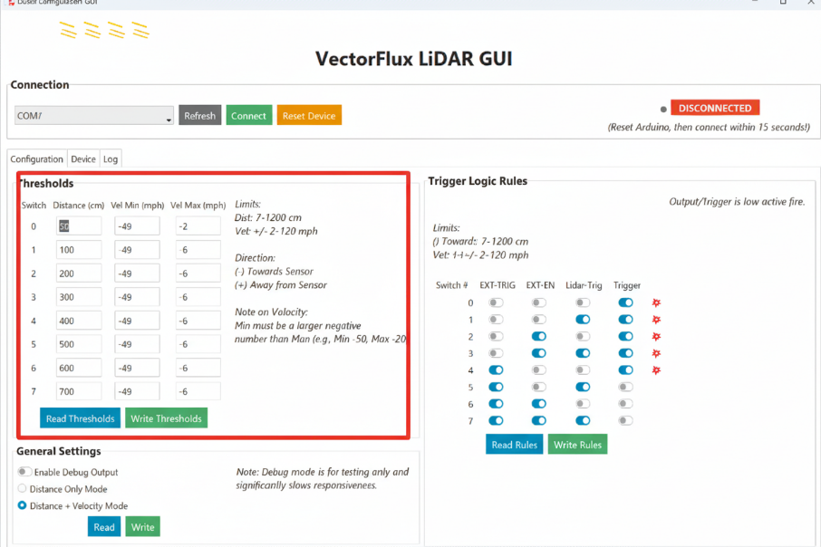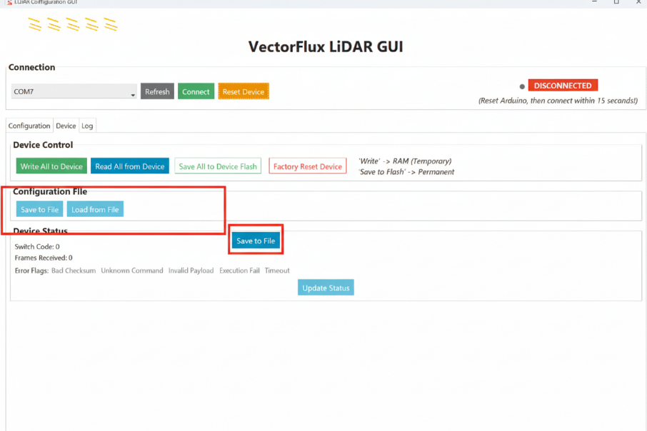Click Load from File to load settings from a .json file into the GUI. (Note: This only loads them into the GUI, not the device. You must still write them to the device).

